Phase-in Reporting Template

[TITLE PROJECT]

[Year and Country]

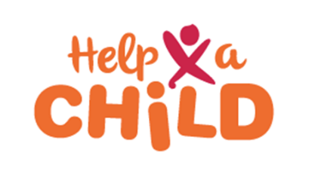
[Insert logo partner organisation]

<Date>
Table of Content

Executive Summary

Turakura Kids Club Selection

Community Challenge Participatory Tools and Assessments

- Collect baseline communication from Turakura families

- Setting up Positive Parenting groups

- PMEAL baseline

- Drafting Mapp and annual plan per district

- Conclusion

Executive Summary
Max ½ page
Briefly outline the key content of the phase-in report.

- “Turakura” Kid’s club Selection
Max ½ page
Outline the criteria for selecting communities from which members for the Kids' Club are chosen, the criteria for selecting Kids' Clubs, and thoroughly document the entire selection process.

Participatory tools and assessments

Please present here the outcomes per step/tool, describe a summary of the findings.

Step 1: Entrance meeting (plenary meeting)

Step 2: Exploring the community (peer group meetings)

Session 2.1: What does the community look like?
Session 2.2 What are the vulnerabilities and capacities of the community and its different groups?

Step 3: Sharing and Caring 1 (plenary meeting)

Step 4: What’s the challenge regarding ECD? (peer group meetings)

Session 4.1: What is the current status of child wellbeing in the community?
Session 4.2: What is the current empowerment status of the community?
Session 4.3 What is the current status of ECD in our community?
Session 4.4 How does parenting look like in our community?

Step 5: Sharing and Caring 2

Step 6: Knowing our strength regarding ECD and drafting our dream

Session 6.1: Individual and community strengths + cause and effect tree.

Session 6.2: What is our dream for young children (0-7 years) in our community?

Step 7: Finding common ground
Session 7.1: To discuss the ToC and Workplan with the community and validate the same, linking it with the challenges, strengths and the Dream of the community (Step 4, 5, 6).
Session 7.2: To include the recommendations of the community in the ToC and Workplan and finalize them.
Session 7.3: To list what external linkages are needed to meet the needs of the community regarding ECD which can’t be covered by the project alone.

Step 8: Setting up the CBCFM system
Report on the following topics:
- Community Information Needs
- Handling Complaints and Feedback
- Inclusion and Diversity

- Collect baseline communication from Turakura families

Setting up Positive parenting Groups and explain how they may evolve into Self-Help Groups
Max 1/2 page
Describe and document the process of establishing positive parenting groups and their integration with the self-help groups (SHGs) approach.

- PMEAL baseline
Max ½ page

- Drafting Mapp and annual plan per district
Max ½ page

- Conclusion
Max ½ page
Highlight key points of the Phase-in by way of summing up the exercise, final considerations, and recommendations as well as challenges during the process can be described here.

