Pressure and Release Model (PAR)
Description: | The Pressure and Release Model helps analyse underlying risk factors, factors contributing to the progression of vulnerability and hazards faced within a community.
Goals of the session: | Analyse and identify different factors contributing to the progression of vulnerability in the community and which hazards play a contributing role to the development of a disaster.
Target group: | Community leaders, men, women, elders and youth (starting from 14 years old).
Preparation time: | 15 minutes.
Duration: | 60-90 minutes.
Materials: | Flipchart, post-it notes, A2 paper and markers.
Copyright: | Freely usable.

Process
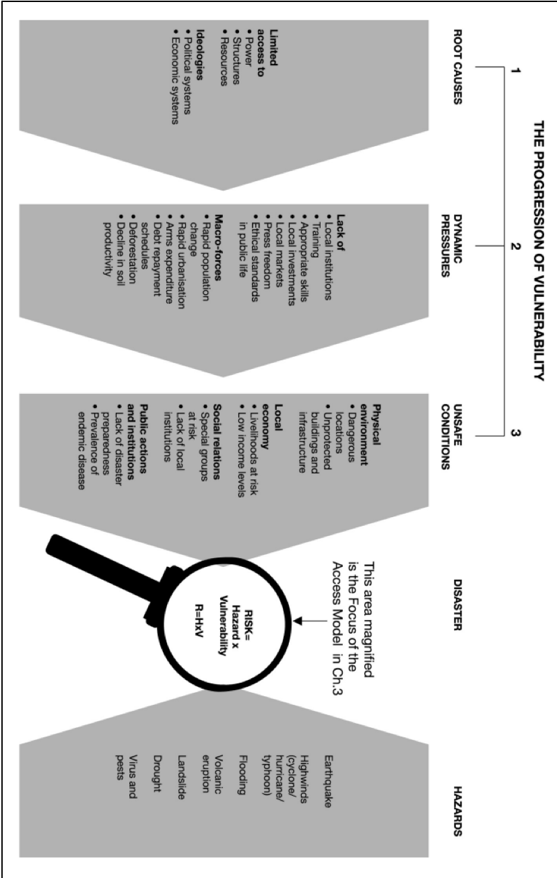
The participants are explained what the PAR model is and how it works. The facilitators bring an A2 sheet of paper with the PAR model on it. The participants are taken through the concepts; progression of vulnerability, root causes, dynamic pressures, unsafe conditions, hazard and disaster. It is important for the facilitators to make sure that the concepts are carefully adjusted to fit the language of the community so that the participants can understand the PAR model properly. It is also important for the facilitator to explain the relation between risk, hazards and vulnerability as seen in the PAR model (Risk = hazard x vulnerability).
The group of participants will be split into even groups if the plenary group of participants is bigger than 20 people. The participants are asked to discuss each aspect of the PAR model among themselves in groups (Root causes, dynamic pressures, unsafe conditions, hazard and disaster). The PAR model itself contains bullet points of discussion for each aspect of the model. An approach to keep each group engaged is to give each group 15 minutes to discuss each aspect of the PAR model. There are guiding questions provided below in this document that the facilitator can use to guide the group onto the next aspect and what should be considered when thinking of, for example, ‘Dynamic Pressures’. This provides the group with clear examples of questions that they can ask themselves in order to identify different risk factors and areas of vulnerability. The groups will each receive an A2 sheet of paper to use when writing out identified aspects part of the PAR model. Post-it notes can also be used to add some colour or highlight important findings. When working through the PAR model, groups should start by identifying root causes, dynamic pressures, unsafe conditions, hazards and then finally the prevalent disaster.
Different information and findings for each aspect of the PAR model can be gathered through different means. Information can be gathered through discussions in the group by reflecting on past experiences or the state of current happenings related to the different PAR model aspects. Depending on the age, gender, roles of the participants different answers and findings will be concluded. This could create a deeper insight when answers are discussed later when all groups come back together. Findings gathered through the Vulnerability and Capacity Assessment, Hazard Assessment and Needs Assessment in the community can also be used to answer questions related to the different aspects of the PAR model.
Reflection: When the 60-90 minutes are over, the groups come together and form a plenary group like in the beginning. The different aspects that have been identified in the groups can be shared and discussed with each other. The facilitator will be in charge of facilitating the discussions and will pose questions in order to create a discussion with the whole group. The community members could be asked whether they understand the risk created through the different vulnerabilities and the occurrence of a hazard? What stands out to them? What have they learnt or realised? The discussion of answers should provide the whole group with new insights and provide understanding in the different aspects contributing to the progression of vulnerability. Especially when a hazard impacts the community and exacerbates the chances of a disaster occurring. Make sure you keep the selected information in your records.

Questions to guide identification of risk factors, vulnerabilities, hazard and disaster.

Root causes
- Which resources are accessible by the community?
- Why might there be limited access to resources?
- Does the community have access to political power?
- Are community members allowed to vote and express opinions?
- Are community members included in political decisions and development of policies?
- Are the economic and social systems fair and inclusive of all community members?
- Do community members benefit from the economic system? Is it stable? Does it provide proper financial care?
Dynamic Pressures
- Are there local institutions like schools, markets, government buildings, banks, hospitals in the community?
- Are community members able to attend school or follow courses/classes that teach new and appropriate skills related to different work fields available in the area?
- Are community members treated properly and with respect? Are the ethical standards of living in the community good (according to basic human rights standards)?
- Is there press freedom in the community?
- Is there an increase in population growth within the community?
- Are community members moving to urbanized areas? Leaving the community?
- How does the community make money? Through selling products in local markets? Arms expenditure? Selling crops and livestock?
- What is the financial state of the community? Do many community members find themselves in debt? Are they being helped?
- Are natural resources still accessible? Is there deforestation in the area? Soil degradation? Decline in soil productivity? Overgrazing? Salinization of the ground?
Unsafe Conditions
- Is the community located in a dangerous location? Disaster-prone area?
- Is the community protected? Is infrastructure strong? Durable? Or are living areas poorly constructed?
- Does the local economy fluctuate regularly? Is there a change in currency from time to time?
- Do local market prices fluctuate?
- Are livelihoods of community members at risk when currencies fluctuate?
- Are livelihoods of community members at risk when local market prices rise or decrease?
- Are income levels of community members high, low, stable? How are income levels for households? (interesting to look at difference between households led by females, males, the elderly or young).
- How are the social relations with the community? Tight-knit community?
- Are there specific groups in the community that are at risk? (members with a disability, elderly who are sick, children who are sick).
- Are these individuals socially accepted with the community?
- Is there a lack in local institutions? (look back at question 1 under ‘Dynamic Pressures’).
- Are community members aware of what disasters and hazards are?
- Are community members prepared for hazards? (Maybe they are aware of the seasonal occurrence of a hazard e.g. flooding, drought, longer rainy periods).
- What measures do community members take to be prepared for hazards?
- Are all community members included?
- Are there endemic diseases within the community? are they reoccurring? Among which age group?
Hazard
- Which hazards does the community face?
- Earthquakes? High winds (cyclone/hurricane/typhoon)? Flooding? Volcanic eruption? Landslides? Drought? Virus and pests?
- Are they man-made or natural?
Disaster
- What type of disaster does the community face? (The combination of the progression of vulnerability and a hazard)
- How many lives have been lost to past disasters?
- Do the community members see the same disasters occurring yearly? Is there a trend?

