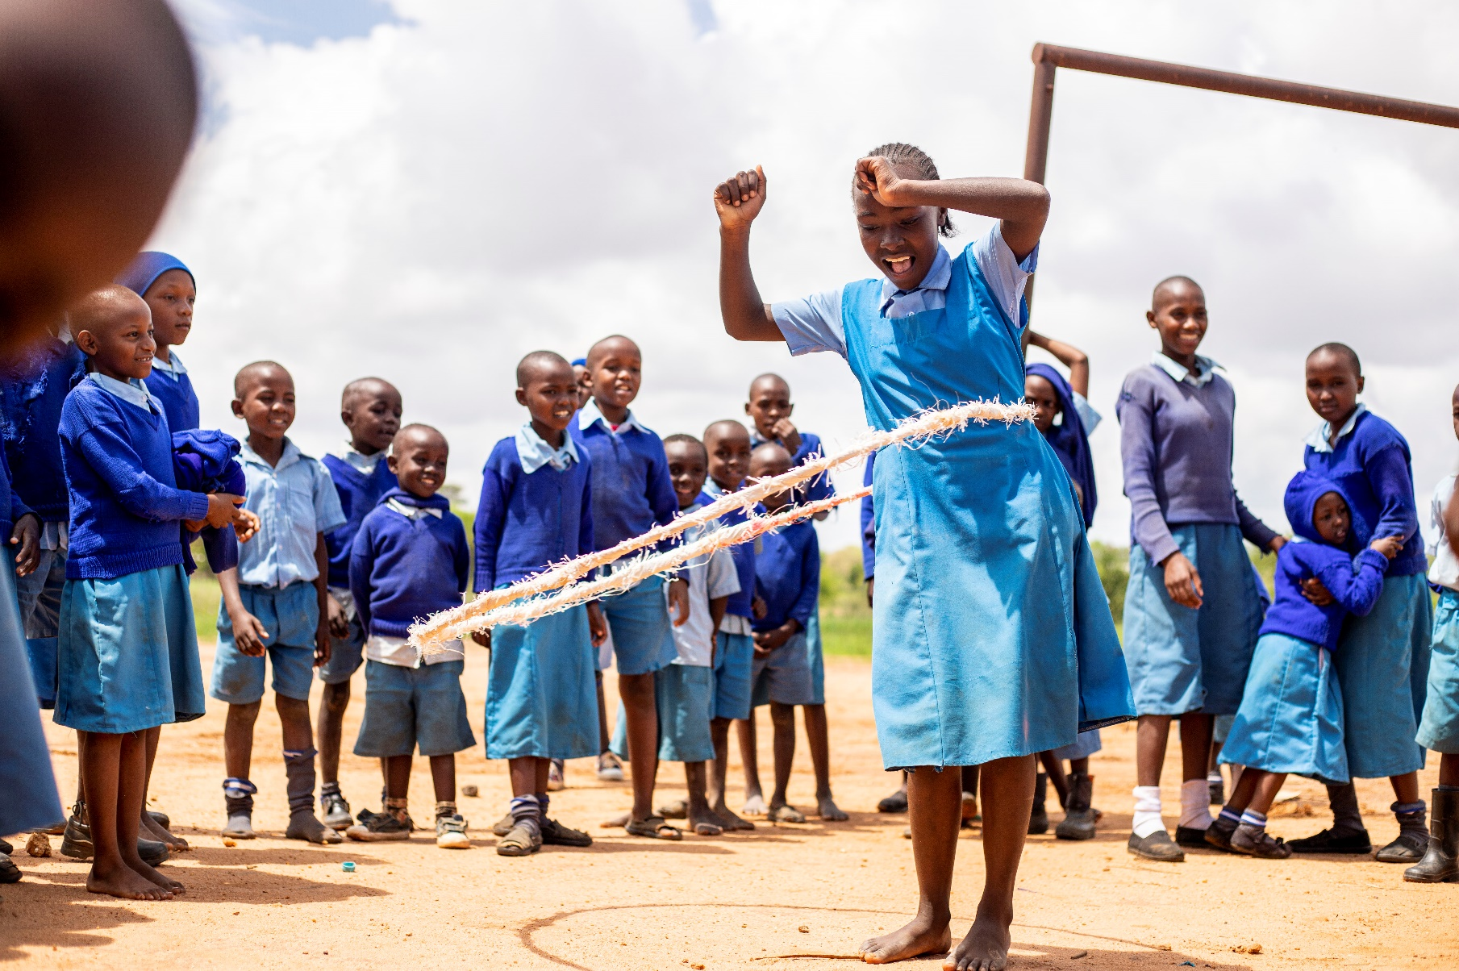

Youth Statements Manual

January 2024
Version 1.0

Youth Statements

Children grow into youth. For sustainability reasons, it is important to know if youth (mainly the target group from 18 – 35) have access to develop themselves within the community. Help a Child's Youth pathway is: ‘’Youth are resilient, confident and economically active’. The long-term objective is formulated as follows: Marginalized youth are empowered, have decent work and grow out of poverty. Therefore, we would like to ask this group the statements in the table below, to get an impression regarding empowerment and decent work. The participants score 1 to 4 per question/ statement (1= far from ideal situation, 2= first steps, 3= moving on, 4= (nearly) ideal situation).

Section
Q1. How do you rate the income opportunities in the area where you live?
Q2. I see a future for youth in this community.
Q3. In our community, the voice of the youth is heard.
Q4. Youth in the community have sufficient practical/ technical knowledge and skills to generate sufficient income.
Q5. Youth in the community have sufficient relevant life skills.
Q6. Youth in the community have sufficient awareness regarding sexual reproductive health (and rights).

Q1. How do you rate the income opportunities in the area where you live?
Guiding principles/ questions:
- Is youth in the community able to generate sufficient income to cater for the basic needs of their families?
- What are the income opportunities in the community? This can be income from self-employment or (in)formal employment.

Q2. I see a future for youth in this community.
Guiding principles/ questions:
- Think of youth in your community in general, not only of yourself.
- Future perspective related to the living environment (peace and harmony)
- Future perspective related to economic opportunities.

Q3. In our community, the voice of the youth is heard.
Guiding principles/ questions:
- Is the voice of youth heard in church, family, and local government?
- Youth feel free to express their opinions towards parents, elderly, family, church, and local government about certain issues that occur in the community.
- Topics: you can discuss different views of youth, gender topics, GBV, etc.

Q4. Youth in the community have sufficient practical/ technical knowledge and skills to generate sufficient income.
Guiding principles/ questions:
- Is the youth in the community adequately trained and has gained skills to generate income?
- Think of trainings like PIP, AVET, Start Your Business. And technical training like tailoring, masonry, bricklaying, electricity, beekeeping, etc. (depending on what is done in the project).

Q5. Youth in the community have sufficient relevant life skills.
Guiding principles/ questions:
- With life skills, we think of social skills, hygiene, entrepreneurship, norms and values.
- How do you present yourselves towards businesses and government officials, etc?

Q6. Youth in the community have sufficient awareness regarding sexual reproductive health (and rights).
Guiding principles/ questions:
- Is the youth trained/sensitised in SRHR?
- Does the youth know how to prevent unwanted pregnancy (pregnancy prevention)?
- What is the safety situation in the community for girls/ young women?

