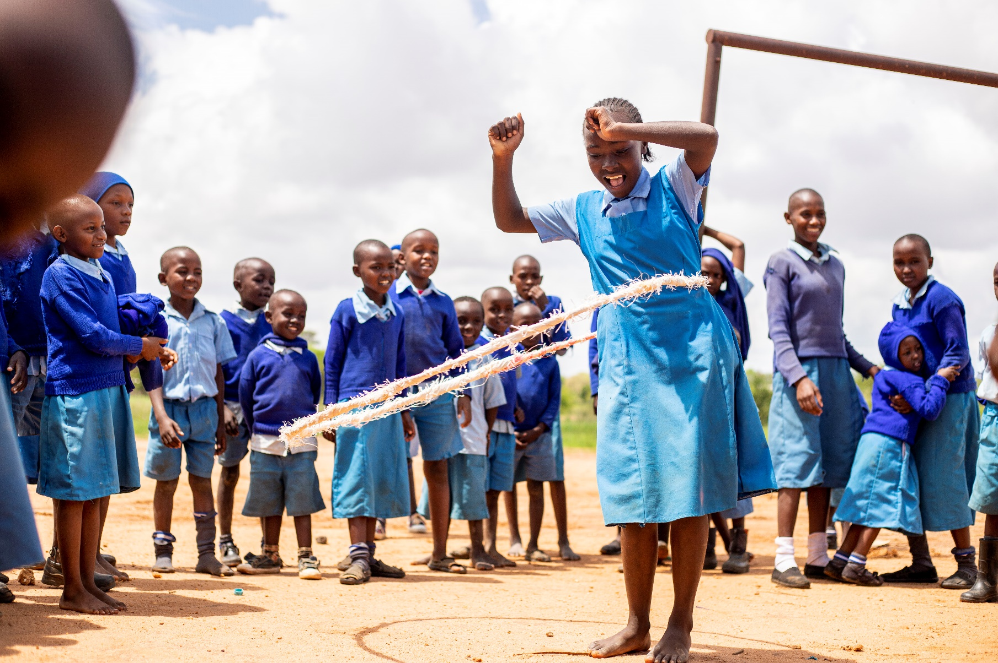
SHG Economics report

Self Help Group Manual

January 2024
Version 1.0

The Self-Help Groups report on their savings and loans. This data is reported once a year to Help a Child in the data sheet (raw data) and in the PMEAL Reporting Framework (totals). The collected data is:

Section
Total number of group members
Total number of female group members
Total number of male group members
Total capital of the group
Total amount of savings last year
Total # of loans
Total amount of loans (in local currency)
Total # loans reimbursed
Total amount of loans reimbursed (in local currency)
Rate of the number of loans to the number of group members (is automatically calculated in the datasheet)

The reasons for taking loans are reporting as well. This is not on the amount but on the number of loans taking for the following reasons:
Section
# of loans for school requirements
# of loans for medical expenses
# of loans for household requirement
# of loans for agricultural investment
# of loans for IGAs
# of loans for other purposes

