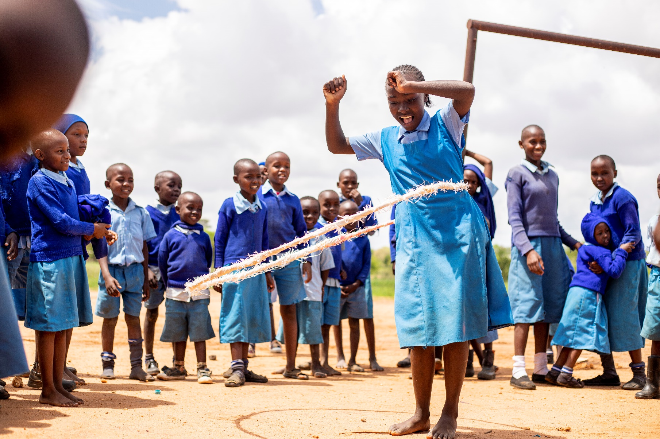
Empowerment Scorecard

Empowerment Scorecard Manual

January 2024
Version 1.0

Why the Empowerment Scorecard
The interventions of organisations supported by Help a Child often include work with groups of people; groups of youths, farmers, community members, women, parents, or others. While such groups often have specific purposes, they often also have the objective to contribute to empowerment of the community as a whole. Getting insight into this empowerment process is difficult. The need for empowerment has resulted into a community empowerment scorecard, where the level of empowerment of the community is measured by the groups.

The community empowerment scorecard offers an instrument to get insight into the status of the community’s empowerment. While groups discuss their empowerment, such discussions may themselves be empowering and lead to further improvements in people’s situations. The intention is that using this community empowerment scorecard leads to direct benefits for the group while it also provides useful information for Help a Child and her partner organisations. The usefulness of this approach will be bigger as the exercise is repeated regularly, such as every six months.

What is empowerment
Empowerment is one of the jargon words in international development and it does not always have much meaning in practice. It is not easily defined and the consequences of empowerment are easier to define than empowerment itself. The three definitions of empowerment below show some of the variety within this concept.

‘The process through which those who are currently disadvantaged achieve equal rights, resources and power’ (Mayoux,2008).

‘The expansion of assets and capabilities of poor people to participate in, negotiate with, influence, control and hold accountable institutions that affect their lives.’ (World Bank Sourcebook on Empowerment, 2002)

‘A multi-dimensional social process that helps people gain control over their own lives’ (Page and Czuba, 1999).

Applied to the type of work that Help a Child and partners often support or implement, we distinguish a number of aspects that could be seen as an operationalization of the concept of empowerment. Other ways of operationalization are also possible. Therefore, this manual proposes that any of these dimensions or categories that is not applicable to a certain situation can be left out, while other dimensions can be added as and when relevant. Also, the specific issues that are related to each of these dimensions can be changed according to each context. In this way we hope that every group using this scorecard will get insights in aspects of empowerment that are relevant to its own situation.

With the Empowerment Scorecard, progress in different domains related to community empowerment can be measured. Groups look at the community as a whole rather than their own group (their near community in their villages) and value their level of community empowerment. It is an outward-looking perspective. This tool can be done with the same group as the Community Group Capacity Scorecard. The participants score 1 to 4 per question/ statement (1= far from ideal situation, 2= first steps, 3= moving on, 4= (nearly) ideal situation). The tool focuses on five areas of empowerment which are:

Domain | Explanation
Enabling environment | Applied to children, this implies that child protection is functional such that abuse of children (sexual, child labour) is almost absent, and dealt with effectively when it happens. Children have opportunities for out-of-school learning, life skill and human development, and they have a right to play.
Ownership | The community is actively engaged in its own developmental processes. There is no dependency mood but rather a "we can do" mentality. Developmental groups in the community have broad acceptance and are able to mobilize the community as a whole.
Self-esteem | This means that people are not being disregarded because of their ethnic group, religion, or because they have certain diseases (e.g. living with HIV) or disabilities. Such (groups of) people themselves also feel they enjoy human dignity and are proud of whom they are.
Resilience | This implies that households are capable to deal with shocks and changes. If market prices turn out to be lower, or some crops fail or weather conditions are unfavourable, households have ways to cope with these adversities. On a personal level, people can cope with sickness and even death of family members.
Access to public services | The main public services (including health, water, sanitation, electricity, agricultural extension, markets) are available to most (if not all) people. Maintenance is also taken care of and costs are reasonable. This is provided by government, or arranged in partnerships with corporate players.
Participation of people and children living with a disability.
Access for people and children living with a disability to products, devices and services.

Enabling save environment
Key issues:
- Structures for protection (in place and functioning)
- Respect for children
- Future perspectives for children

Far from ideal situation (1) | First steps (2) | Moving on (3) | (Nearly) ideal situation (4)
The community is a difficult place for children, as they do not receive the love and respect they deserve. Child protection is not functioning, even if laws and policies for protection are in place, they are not functional. It doesn’t seem as if this will change in the near future, resulting into negative future perspectives for children in this area. | Not defined, use intuitively | Not defined, use intuitively | The community is a good place for children to grow up in. Children are generally loved and respected. Child protection is functional such that abuse of children (sexual, child labour) is almost absent, or dealt with effectively. It seems as if this will remain in the future; making the community a place full of positive future perspectives for children.

Ownership
Key issues:
- Engagement in community developmental processes
- Attitude of dependency
- Legitimacy and activity of community groups, including broad mobilization

Far from ideal situation (1) | First steps (2) | Moving on (3) | (Nearly) ideal situation (4)
The community is little active in its own development or has a spirit of dependency, expecting all support from outside sources. Developmental groups, if present, do not have broad support in the community or are not able to mobilise many people. | Not defined, use intuitively | Not defined, use intuitively | The community is actively engaged in its own developmental processes. There is no dependency mood but rather a "we can do" mentality. Developmental groups in the community have broad acceptance and are able to mobilize the community as a whole.

Self-esteem
Key issues:
- Absence of stigma (ethnic, religious, diseases, disabilities)
- Sense of human dignity (incl. spiritual), worth, equality to others, pride and satisfaction about self and the community at large

Far from ideal situation (1) | First steps (2) | Moving on (3) | (Nearly) ideal situation (4)
The community is not proud of themselves and it's members, but rather feel ashamed and don't believe in the good they can do as a community. Also individual community members are being stigmatized for one or more reasons including ethnicity, religion, diseases or disabilities. | Not defined, use intuitively | Not defined, use intuitively | The community works in a united way. People are convinced of the added value each of it's members, and are proud of their strength as a community and their diversity. People are not being disregarded because of their ethnic group, religion, certain diseases (e.g. living with HIV), disabilities are any other reason. All members in the community feel they enjoy human dignity and are satisfied with whom they are and take pride in what they do in the community.

Resilience
Key issues:
- Dealing with changing market issues (incl. prices)
- Coping with sickness and death
- Dealing with adverse weather conditions
- Dealing with natural hazards
- Dealing with other shocks

Far from ideal situation (1) | First steps (2) | Moving on (3) | (Nearly) ideal situation (4)
If negative shocks occur, such as lower market prices for crops, bad weather, poor harvests, disaster, sickness or death, households easily fall back into more severe poverty than before and struggle to overcome these difficulties. | Not defined, use intuitively | Not defined, use intuitively | Single households, but also the community at large is capable of dealing with shocks and changes. If market prices turn out to be lower, or some crops fail or weather conditions are unfavourable, the community and it's members have ways and effective strategies to cope with these adversities. The overall quality of live is not reduced by the shock. On a personal level, people can cope with sickness and even death of family members.

Access to public services
Key issues:
- Availability, affordability, quality of health services, water, sanitation, electricity, agricultural (extension, inputs, market structures), or other services that the government should officially provide
- Government assistance in times of crisis

Far from ideal situation (1) | First steps (2) | Moving on (3) | (Nearly) ideal situation (4)
Public services are not available. And if they are available, they are only for few people or maintenance is very poor, making them ineffective. Government does not give assistance in times of crises. | Not defined, use intuitively | Not defined, use intuitively | The main public services (including health, water, sanitation, electricity, agricultural extension, markets) are available to most (if not all) people. Maintenance is also taken care of and costs are reasonable. This is provided by government, or arranged in partnerships with corporate players. The government assists the community in times of adversity.

Participation of people and children living with a disability

Far from ideal situation (1) | First steps (2) | Moving on (3) | (Nearly) ideal situation (4)
People and children living with a disability are not able to participate in the community at all. | Not defined, use intuitively | Not defined, use intuitively | People and children living with a disability can fully participate in the community.

Access for people and children living with a disability to products, devices and services

Far from ideal situation (1) | First steps (2) | Moving on (3) | (Nearly) ideal situation (4)
People and children living with a disability do not have access to products, devices and services at all. | Not defined, use intuitively | Not defined, use intuitively | People and children living with a disability have full access to products, devices and services.

All as cited in Jupp, D., Ali, S. I., & Barahona, C. (2010). Measuring empowerment? Ask them. Sida Studies in Evaluation.

