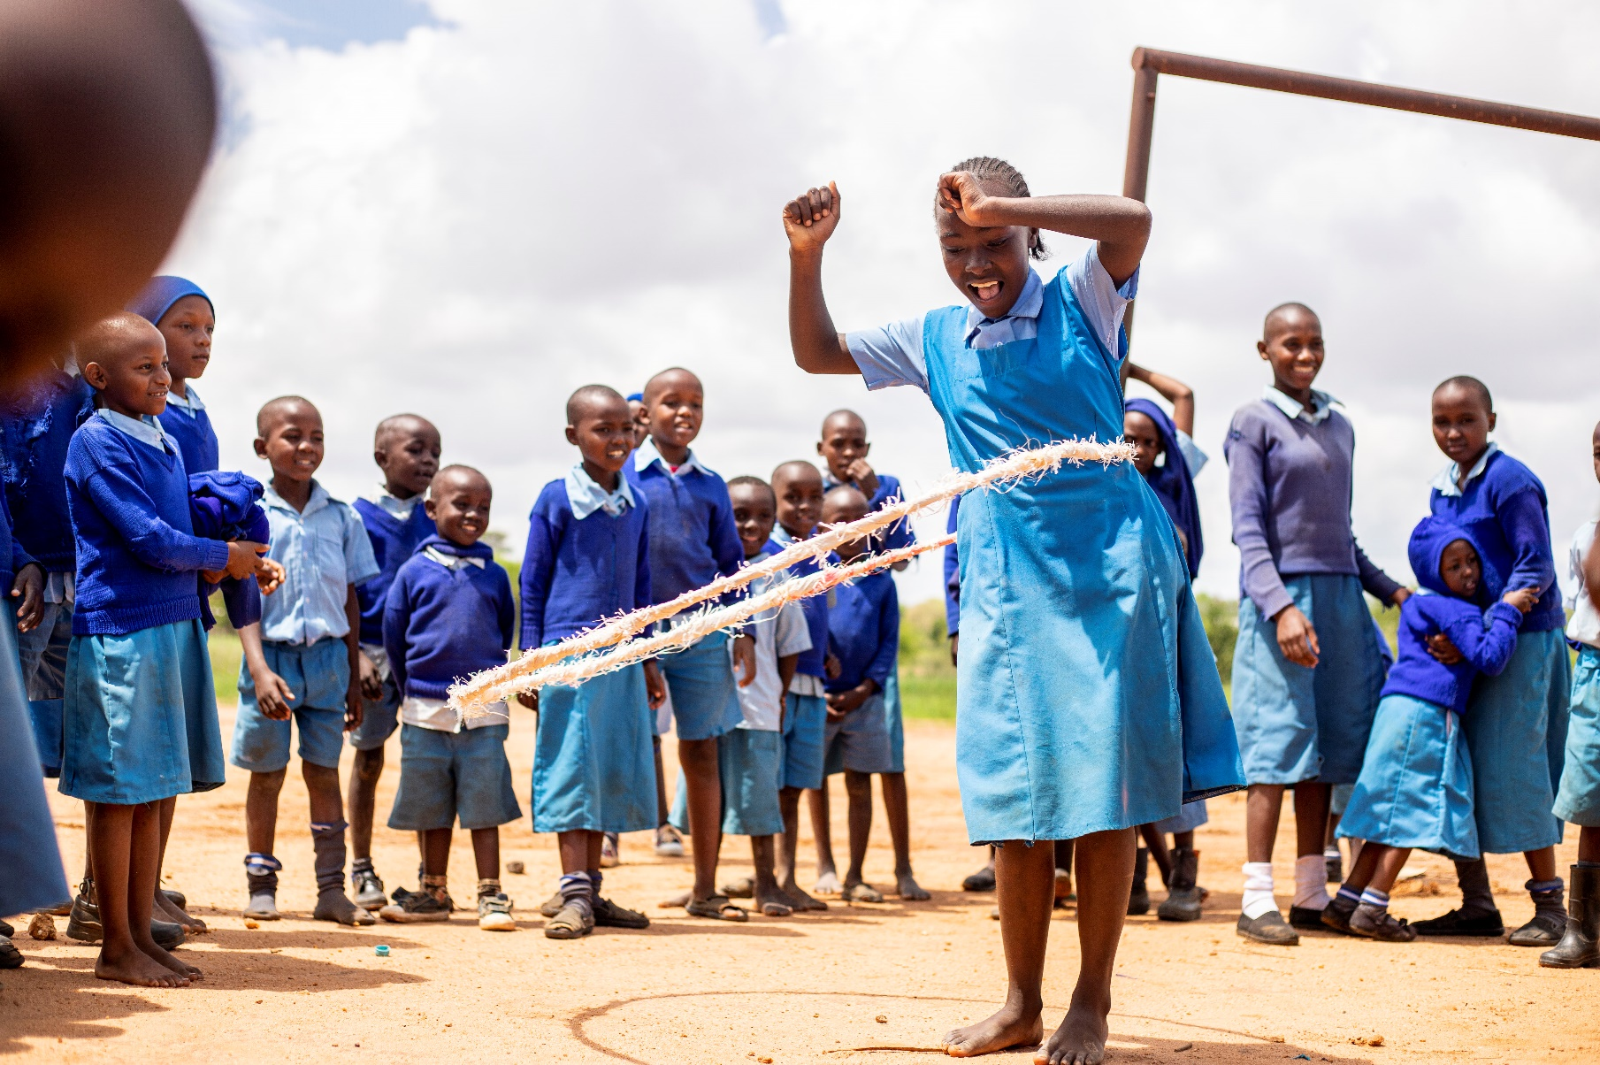
ECDC Scorecard

ECDC Scorecard Manual

January 2024
Version 1.0

The ECDC Scorecard measures the quality of the ECD centres. The first time this tool is being used as a baseline, it should be done with the Help a Child and partner staff, together with the ECD Committees (if already formed). The Help a Child and partner staff score the categories and simultaneously guide the new ECD Committee in evaluating the categories. The participants score 1 to 4 per question/ statement (1= far from ideal situation, 2= first steps, 3= moving on, 4= (nearly) ideal situation).

The baseline is done at the start of the project for every ECD centre that is part of the project and for every new ECD centre that is opened during the project. From the second time onwards, the Help a Child and/or partner staff conduct the tool with the ECD committee but do not score themselves anymore. The ECDC scorecard is done every other year and should be done for every ECD centre in the project.

The topics to discuss are:

Section | Category
Section A – Access to Education | Q1. Enrolment
Section A – Access to Education | Q2. Attendance Rate
Section A – Access to Education | Q3. Inclusion
Section B – Teaching & Learning Quality | Q4. Teacher Qualifications and Skills
Section B – Teaching & Learning Quality | Q5. Use of Pre-primary curriculum
Section B – Teaching & Learning Quality | Q6. Positive Discipline
Section C – Learning and Play Materials | Q7. Use of Locally Available Materials
Section C – Learning and Play Materials | Q8. Books
Section D – Healthy & Safe Facility | Q9. Physical Infrastructure
Section D – Healthy & Safe Facility | Q10. Learning Space
Section D – Healthy & Safe Facility | Q11. Child Protection
Section D – Healthy & Safe Facility | Q12. Hygiene and Sanitation
Section D – Healthy & Safe Facility | Q13. Space for Outdoor Play
Section E – Management | Q14. Management Committee
Section E – Management | Q15. Parental Participation
Section E – Management | Q16. Teacher Retention
Section E – Management | Q17. Sustainability
Section E – Management | Q18. Transition to Primary
Section E – Management | Q19. Community Outreach
Section F – Holistic Service Provision | Q20. School Feeding
Section F – Holistic Service Provision | Q21. Health Services
Section F – Holistic Service Provision | Q22. Parenting Education
Section F – Holistic Service Provision | Q23. Linkages

Q1. Enrolment

Far from ideal situation (1) | First steps (2) | Moving on (3) | (Nearly) ideal situation (4)
A small percentage of children from the surrounding community are enrolled | Less than 50% of children from the surrounding community are enrolled | More than 50% of children from the surrounding community are enrolled | Most children from the surrounding community are enrolled

Q2. Attendance Rate

Far from ideal situation (1) | First steps (2) | Moving on (3) | (Nearly) ideal situation (4)
Almost all children are very frequently absent – either due to illness, inability to pay, or little value placed on the importance | More than 50% of the children are often absent | Less than 50% of the children are often absent | Most children are present consistently – with few exceptions due to illness

Q3. Inclusion

Far from ideal situation (1) | First steps (2) | Moving on (3) | (Nearly) ideal situation (4)
Children with disabilities or special learning needs are turned away because there are no services for them | The services are accessible for children with a disability, but no children with disabilities or special learning needs are included | A few children with disabilities or special learning needs are included. The services are accessible, but the teacher/caregiver lacks knowledge and skills on how to include children with a disability. | Most children with disabilities or special learning needs are included and outreach is done to encourage parents to send all children. The services are accessible and the teacher/caregiver has the capacity to include children with a disability.

Q4. Teacher Qualifications and Skills

Far from ideal situation (1) | First steps (2) | Moving on (3) | (Nearly) ideal situation (4)
The teacher/caregiver is untrained and unable to use playful methodology that stimulates active learning and participation of children | The teacher/caregiver is trained but teaches in a traditional fashion that is teacher-centred (little or no playful methodology) | The teacher/caregiver has received some specific ECE training and tries to use some active learning techniques and playful methodology | The teacher/caregiver is well trained and experienced in ECE and makes use of mixed methods, even giving time for free play in learning corners

Q5. Use of Pre-primary curriculum

Far from ideal situation (1) | First steps (2) | Moving on (3) | (Nearly) ideal situation (4)
The center does not have a copy of the national’s pre-primary curriculum and the teacher/caregiver does not know the contents | The center does not have a copy of the national’s pre-primary curriculum, but the teacher/caregiver has received some information about the contents and approaches | The center has a copy of the national’s pre-primary curriculum, but the teacher/caregiver does not understand very well how to use it to plan and link daily lessons | The center has a copy of the national’s pre-primary curriculum and the teacher/caregiver uses it to plan lessons in a thematic and integrated way

Q6. Positive Discipline

Far from ideal situation (1) | First steps (2) | Moving on (3) | (Nearly) ideal situation (4)
The teacher/caregiver does not have strategies to manage the children so they are left to run around, shout and misbehave | The teacher/caregiver imposes strict discipline but in a harsh way so that the children sit quietly but are not active or free | The teacher/caregiver has a warm way with children but has some challenges with control | The teacher/caregiver responds to misbehavior in a firm but kind way and teaches children the expected behavior

Q7. Use of Locally Available Materials

Far from ideal situation (1) | First steps (2) | Moving on (3) | (Nearly) ideal situation (4)
The classroom has furniture but no materials that children can use for learning and play during lessons | The center has some materials for learning and play, but they are locked away in storage most of the time for safekeeping and only brought out rarely | The teacher/caregiver and parents have actively gathered locally available materials and they are brought out for use by children for certain activities | The teacher/caregiver and parents have actively gathered many collections of materials which are visible in the room and used daily by children

Q8. Books

Far from ideal situation (1) | First steps (2) | Moving on (3) | (Nearly) ideal situation (4)
The classroom has no books | The classroom has few books which the teacher uses for read aloud | The classroom has some books, purchased and hand-made, which both teacher and children use occasionally | The classroom has a collection of books, purchased and hand-made, which children have a chance to look at on daily basis

Q9. Physical Infrastructure

Far from ideal situation (1) | First steps (2) | Moving on (3) | (Nearly) ideal situation (4)
No special infrastructure exists for the ECDC – it uses shared space | One special classroom has been built for all children | At least 2 separate rooms have been constructed with toilets | A full complement of classrooms, storage room, toilets and a kitchen have been constructed, which is disability accessible and in line with national standards
Q10. Learning Space

Far from ideal situation (1) | First steps (2) | Moving on (3) | (Nearly) ideal situation (4)
The classroom is unfinished, unsafe and not designed for use by children | The classroom is finished but has elements which make it not very safe and suitable for learning (too small, dark, dirty, not child-friendly) | The classroom is safe and suitable for learning but small for the number of children and doesn’t allow for a variety of seating arrangements (tables, mats) | The classroom is in line with national standards. It is safe, child-friendly, well-lit, airy, and is big enough to have space for ‘circle time’ on mats as well as seated work at tables

Q11. Child Protection

Far from ideal situation (1) | First steps (2) | Moving on (3) | (Nearly) ideal situation (4)
Teachers/caregivers don’t have knowledge of the code of conduct and policies on child safeguarding, Teachers/caregivers didn’t receive any training on Child Protection issues, Children are often not supervised and/or corporal punishment takes place. | Teachers/caregivers have little knowledge of the code of conduct and policies on child safeguarding. Teachers/caregivers received some training on Child Protection issues. There is some attention for positive disciplining but corporal punishment still takes place. | Teachers/caretakers understand the Child Safeguarding Policy and signed the aligned Code of Conduct. Teachers/caretakers received training on Child Protection issues and positive disciplining. There is in general good supervision and no corporal punishment. | Teachers/caretakers understand the Child Safeguarding Policy and signed the aligned Code of Conduct. Teachers/caretakers are trained on how to identify and respond to CP issues. The ECD is linked to Child Protection Committees. Children are always supervised and there is no corporal punishment.

Q12. Hygiene and Sanitation

Far from ideal situation (1) | First steps (2) | Moving on (3) | (Nearly) ideal situation (4)
There are no WASH facilities specific for the ECDC (toilets are shared) | There are some WASH facilities (separate toilets or handwashing stations), but they are not functioning properly or cleaned regularly | There are separate WASH facilities but due to a shortage of water they are only functional or cleaned some of the time | WASH facilities are in line with national standards. There is water available and WASH facilities (separate toilets and handwashing stations) are well-maintained and used

Q13. Space for Outdoor Play

Far from ideal situation (1) | First steps (2) | Moving on (3) | (Nearly) ideal situation (4)
There is no safe space for outside play. There is no space, or the space has many safety hazards | There is limited space for outdoor play and/or play equipment is broken or dangerous | There is enough space for outdoor play, but there is no fence around the compound and/or play equipment is broken or dangerous | The outdoor play space is in line with national standards. It is fenced, and has a play area set up with some simple and safe toys

Q14. Management Committee

Far from ideal situation (1) | First steps (2) | Moving on (3) | (Nearly) ideal situation (4)
There is no active ECD management committee | The ECD management committee exists but is not trained on its role and does not meet regularly | The ECD management committee exists and meets termly but focuses mainly on fee collection | The ECD management committee is active in mobilizing parents, coordinating learning events, following the quality of the ECD center and linking with stakeholders

Q15. Parental Participation

Far from ideal situation (1) | First steps (2) | Moving on (3) | (Nearly) ideal situation (4)
Parents rarely pay fees (or in-kind contributions) and rarely come to general meetings or other events | Parents struggle to pay fees (or in-kind contributions) regularly but do come to general meetings or other events | Parents try their best to pay fees (or in-kind contributions) regularly and participate actively in general meetings or other events | Parents mostly pay fees regularly (or contribute via in-kind contributions) and actively support the center by doing volunteer jobs and giving in-kind contributions to help the ECDC

Q16. Teacher Retention

Far from ideal situation (1) | First steps (2) | Moving on (3) | (Nearly) ideal situation (4)
Teacher/caregiver turnover is frequent due to lack of payment, lack of collaboration, or other factors – even daily attendance can be problematic | Recruited teachers/caregivers frequently leave when they find better options – but attendance and commitment are good while in the role | Turnover happens sometimes but the management committee looks for teachers/caregivers with passion and stability when recruiting | Teachers/caregivers are stable due to close collaboration with parents who ensure they are paid and not overburdened

Q17. Sustainability

Far from ideal situation (1) | First steps (2) | Moving on (3) | (Nearly) ideal situation (4)
The center is unable to pay the teachers/caregivers or cover other operational costs | The center tries to do its best to manage the limited funds it collects from parents alone | The center has at least one creative strategy for mobilizing additional funds or donations which can top-up parental payments | The center has established its own income generating project which brings in enough funds to cover a holistic program

Q18. Transition to Primary

Far from ideal situation (1) | First steps (2) | Moving on (3) | (Nearly) ideal situation (4)
The center has no relationship with a primary school – children scatter when entering P1 | The center is known by the government education officer but there is no direct relationship with a nearby primary school | There is a nearby primary school and the headteacher knows about the center (as well as the government education officer) and welcomes children positively | The linkage to a nearby primary school is strong – the headteacher gives some support to teachers and the ECDC brings children for a visit prior to transition

Q19. Community Outreach

Far from ideal situation (1) | First steps (2) | Moving on (3) | (Nearly) ideal situation (4)
No efforts are made to educate other parents on the importance of ECD and enroll their children | Community meetings are held (at the beginning of the year) to mobilize parents to send their children | Parent committee members and/or teachers/caregivers try to raise the issue of the importance of ECD whenever there is an opportunity | Parent committee members and teachers/caregivers along with local leaders have a strategy for continuously mobilizing parents to bring their children to ECDCs

Q20. School Feeding

Far from ideal situation (1) | First steps (2) | Moving on (3) | (Nearly) ideal situation (4)
There is no meal provided to children at school | There is no meal provided to children but most families are able to pack, and food is shared so that all children eat | There is a feeding program in place to provide porridge but the quality is poor or irregular due to limited resources | There is a daily feeding program in place that provides quality porridge for all children

Q21. Health Services

Far from ideal situation (1) | First steps (2) | Moving on (3) | (Nearly) ideal situation (4)
There is no connection between the ECDC and the local health center or CHW (community health workers) | There is connection between the ECDC and the local health center or CHW (community health worker). Parents are sensitized during general meetings to bring their children to the local health center | The CHW or nurse comes to the ECDC to monitor the growth of children | The CHW or nurse comes to the ECDC to monitor the growth of children AND organizes education events for parents on health topics

Q22. Parenting Education

There are no learning events for parents beyond general meetings | At least once a term there is a special presentation for parents on a topic such as child protection, health, or play, this may be combined with a general meeting | There is a regularly scheduled learning event for parents that takes place at least once a month and covers a variety of topics with guest speakers | In addition to a regular program of learning events for all parents, intensive parenting classes are offered for cohorts of parents at time – parents of 0-3 are specifically included

Q23. Linkages

Far from ideal situation (1) | First steps (2) | Moving on (3) | (Nearly) ideal situation (4)
The center is operating in isolation – few people are aware and no one but parents contribute | The center is known by local leaders who make some non-monetary contributions | The center has been able to advocate for some government funds or services – within various sectors (education, health, nutrition, child protection) | The center has multiple sources of financial and technical support (government and donor) and is maximizing use of existing resources and services

Q24. Integrated Nutrition and ECD interventions

Far from ideal situation (1) | First steps (2) | Moving on (3) | (Nearly) ideal situation (4)
No education or specific interventions in the area of nutrition take place. | Nutrition education/messaging (on breastfeeding and complementary feeding) takes place. There are single/temporary interventions to promote well-nourishment of children. | Nutrition education/messaging (on breastfeeding and complementary feeding) takes place. There are regular interventions to promote well-nourishment of children. | Nutrition messages and services are integrated part of ECD services. This can include: ongoing education/ messaging (on breastfeeding and healthy food), distribution of dietary supplements, referral for malnourished children, home visits, kitchen garden at the ECD center etc.

