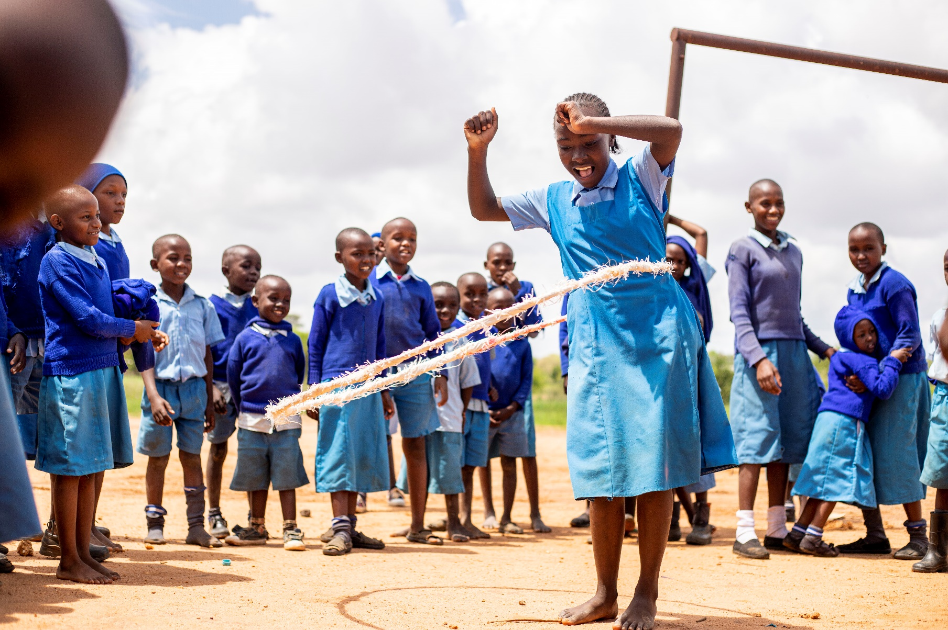

Child Status Index Manual

January 2024
Version 1.0

Child Status Index
December 2023, version 4.0 – Help a Child

The Child Status Index is closely related to Help a Child’s overall goal: improved wellbeing for all children. The Child Status Index measures the wellbeing of children on the physical, social-emotional and cognitive domains. Within our CCCD projects, the Child Status Index is used as a group-based tool, meaning that groups of children and groups of adults sit together to discuss and score the different themes. The participants score 1 to 4 per question/ statement (1= very bad, 2= bad, 3= fair, 4= good). The themes are:

Domain | Category
Physical | Food Security
Physical | Health Care Service
Cognitive | Education and Work
Social/ emotional | Care
Social/ emotional | Abuse and Exploitation
Social/ emotional | Emotional Health
Social/ emotional | Social Behaviour

The Child Status Index is administered with both children groups and adult groups. It can be done with groups like SHGs, children groups, youth groups or CLAs.

Food Security
Key Issue: Quantity of food and frequency of meals

- How many meals do most children eat per day?
- Do children often complain of hunger?
- What are the main challenges families face in providing enough food for their children?
- Tell me about times when there is no or less food. Does this depend on the harvest season?

1 - very bad | 2 - bad | 3 - fair | 4 - good
Children rarely have food and go to bed hungry most nights | Children frequently have less food to eat than they need and complain of hunger | Children have enough to eat some of the time, depending on the season or food supply | Children are consistently well fed and eat regularly

Health Care Services
Key Issue: Access to preventative and curative health treatment by professional doctors or nurses

- What happens when children fall ill? How are they treated?
- When children need medicine, how do people get it?
- Tell me about health services the children need but do not receive. What are the barriers?
- Do most children receive vaccinations to prevent illness?
- Has anyone talked to children about risks for HIV/AIDS and how to protect against these risks?

1 - very bad | 2 - bad | 3 - fair | 4 - good
Children rarely receive healthcare services from professionals | Children only sometimes receive the health services that they need | Children receive treatment when they are ill but some services are missing (preventative or curative) | Children generally receive all necessary healthcare treatments and preventative services that they need

Education
Key Issue: Regular attendance at school

- Are most children enrolled in school – at pre-primary, primary or secondary levels?
- Do children attend school regularly?
- What are the main barriers to accessing education? (i.e. distance, fees)
- How often do children miss school? What are the common reasons for poor attendance?
- At what level do children often drop out of school?

1 - very bad | 2 - bad | 3 - fair | 4 – good
Many children are not even enrolled in school, especially at pre-primary level, and attendance is poor | Many children are enrolled in school but many rarely attend, others are not even enrolled | Most children are enrolled in school, but not at every level, and attendance can be irregular | Most children are enrolled in school, even at the pre-primary level, and attend regularly

Care
Key issues: Love and attachment received through caring interactions with adults

- Are there many semi-orphans and orphans in this community?
- Who to children express their feelings to – whether positive or negative?
- How often do you see parents or caregivers talking to and playing with their children?
- When children are crying or hurt, how do adults usually respond? (Are they comforted when this happens by loved ones OR ignored and told to keep quiet?)
- Do children generally feel free and happy with their teachers and parents/caregivers? Or are they often fearful?

1 - very bad | 2 - bad | 3 - fair | 4 - good
In our community, many children have to care for themselves because there are no adults in their household who are taking responsibility in care for them | Many children in our community lack consistent adult caregivers around them and do not receive love, attention, and support | Children have adult caregivers who are present but these adults may spend little time with them and are concerned mostly with physical issues (i.e. food, health) | In this community, almost all children have adult caregivers who are involved in their lives and actively protect and show love to children

Abuse and Exploitation
Key issues: Cases of physical, emotional, and sexual abuse, neglect, or child labour

- Are there many cases of physical child abuse in this community? Sexual abuse?
- Do children and parents know about child rights? And respect them?
- What are the biggest threats to child safety and protection?
- How much household work are children responsible for?
- Do children often miss out on schooling or other child-activities due to responsibility to work?

1 - very bad | 2 - bad | 3 - fair | 4 – good
There is a high number of cases where children are abused physically, sexually, or forced to work in our community. | Many children in our community are ignored, ill-treated, or asked to do work that is inappropriate for their age | Children are not supervised very closely so there is the possibility children are not treated well | Almost all children in our community are protected from physical, emotional and physical abuse. Children are closely supervised, and are not asked to do heavy or inappropriate work

Emotional Health
Key issues: Experience a normal range of emotions but are generally hopeful and positive

- Are children happy or sad most of the time?
- How can you tell if children are happy or unhappy?
- What makes children sad, worried, or fearful?
- Do children (especially adolescents) have positive dreams for their future?

1 - very bad | 2 - bad | 3 - fair | 4 - good
Many children in this community are hopeless, sad, and prefer to be alone | Children often appear sad, upset, fearful and withdrawn | The majority of children in this community appear happy in some situations but may be isolated and act shy in public | Almost all children are generally happy and hopeful about the future

Social Behaviour
Key issues: Respectful attitude towards others and ability to cooperate with peers

- How do children behave towards adults?
- Do children need to be punished often? For what types of behaviours?
- Do children have time to play and interact with other children their age?
- Do children fight a lot with each other?
- What worries do you have about children’s behaviour in the community?

1 - very bad | 2 - bad | 3 - fair | 4 - good
Many children display anti-social or risky behaviour such as lying, stealing, hurting others, etc. | Many children are disobedient with adults and get into frequent fights with peers | Children have some problems getting along with peers or adults | Children play well with peers and participate easily in group activities

