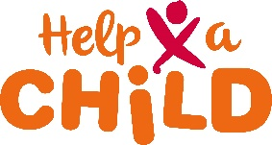
Reporting form

In case of a Child Protection concern whereby one of the staff, intern, consultant or volunteer of Red een Kind may be involved, you are requested to report this. Fill in the form and send it to the Child Protection Officer of REK: childprotection@redeenkind.nl It is important to provide as much as possible details of what was observed. NB. IMPORTANT: mark the form clearly as CONFIDENTIAL!!!

Name of person reporting
Name
Position
Contact details
Date of reporting

Description of the Child Protection Concern
What happened?
Where did it happen?
When?
(date and time)
Who was involved as alleged staff/intern/ consultant/volunteer of REK?
What are details of the child involved?
Any other witnesses?

Intervention so far
What was done so far?

Action taken by REK (CPO and MT)
Case report built
Investigation of the situation
Support for child (and family) arranged
Accused staff member heard
Action taken
Status of allegation | Dropped, since not true | Internally sorted (breach of Code of Conduct, but no abuse of children) | Referred to legal authorities

