Phase-out Plan [Mention full length of this phase-out plan]

[TITLE PROJECT]

[Insert logo partner organisation]

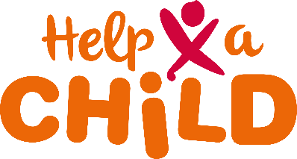

Submitted : [Date]

**Project summary**

|  |  |
| --- | --- |
|  | **Project Summary** |
| **Project title** | [Project title] |
| **Total project period** | [full length of the MAPP] |
| **Name lead organization** | [Name of the lead organization] |
| **Name other implementing organization(s)** | [Name of other organizations also implementing parts of this project (if applicable)] |
| **Total annual budget** | [Total annual budget proposed for each year of phase-out] |
| **Division budget** | [Division of budget per partner in consortium for each year of phase-out (if applicable)] |
| **Intervention area** | [name of the location(s) where you are implementing the project] |
| **Number of households in intervention area** | [estimation of number of households] |
| **Number of children/ youth in intervention area** | * [estimation of number of children (0-18 years)] * [estimation of number of youth (19-25 years)] |
| **Targeted number of households** | [how many of the households in the intervention area will you reach this year] |
| **Targeted number of children & youth** | * [how many young children (0-7) in the intervention area will you reach this year]* * [how many children (8-12) in the intervention area will you reach this year]* * [how many adolescents (13-18) in the intervention area will you reach this year]* * [how many youth (19-25) in the intervention area will you reach this year]*   *Age brackets can be contextualised |
| **Number of children/ families linked to a sponsor** | [xxx number of registered children/ family ambassadors linked with a sponsor] |
| **Long-term outcome** | [long-term outcome of the project as defined by ToC] |
| **Pathways of change** | [list the outcome description per pathway of change in your ToC, often these are thematic outcomes]   * … * … * … * … * … |

**Contact information Partner Organisation(s)**

|  |  |
| --- | --- |
|  | **Partner organisation 1** |
| **Partner organisation (lead)** |  |
| **Country** |  |
| **CEO** | [name CEO] |
| **Project manager** | [name project manager] |
| **PMEL officer** | [name PMEL officer] |
| **Sponsorship officer** | [name sponsorship officer] |
| **Other staff involved** |  |
| **Email address and Phone number contact person** | [name, email and phone number person assigned as contact person for Help a Child responsible for submission] |

|  |  |
| --- | --- |
|  | **Partner organisation 2** |
| **Partner organisation (other)** |  |
| **Country** |  |
| **CEO** | [name CEO] |
| **Project manager** | [name project manager] |
| **PMEL officer** | [name PMEL officer] |
| **Sponsorship officer** | [name sponsorship officer] |
| **Other staff involved** |  |
| **Email address and Phone number contact person** | [name, email and phone number person assigned as contact person for Help a Child responsible for submission] |

**Contact Information Help a Child**

|  |  |
| --- | --- |
|  | **Contact data Help a Child** |
| **Organization name** | Help a Child |
| **Postal address** | Postbus 40169 | 8004 DD Zwolle | The Netherlands |
| **Visiting address** | G. Stephensonstraat 11  8013 NL Zwolle, The Netherlands |
| **Telephone number** | +31(0)38 460 46 48 |
| **E-mail** | [projects@redeenkind.nl](mailto:projects@redeenkind.nl) |

**1 Programme description**

**1.1 | Outcomes of the MAPP to be implemented**

Shortly mention the key elements or the particular part of the Theory of Change in your Multi-Annual Project Plan (MAPP, previously referred to as SPP) that you are going to implement these final years (Max 1 A4)

**1.2 | Changes in comparison to MAPP**

Explain, if applicable, changes in target group(s) and beneficiaries as well as other relevant contextual changes (environment, social or political) compared to the Multi-Annual Project Plan. (Max ½ A4)

Explain, if applicable, changes in strategy, approach, theory of change etc. compared to the MAPP. Justify why you decided for these changes (e.g. based on changed context, feedback from the community, different needs, unintended negative consequences, etc.). (Max ½ A4)

**1.3 | Context Analysis**

Provide an overview of important changes in the context of the project with its implications for implementation in these final years. Please pay also specific attention to potential risks that may jeopardize the realization of (some) activities and describe how they are dealt with, also make a qualification of these risks. (Max ½ A4)

**1.4 | Description of planned activities for the final years of the project**

Describe, per pathway of change the activities that you have planned for these final years. In your MAPP you have listed the main activities over the years, in this paragraph you work-out more detailed activities. In paragraph 1.5 there is room for showing when you plan these specific yearly activities.

Be SMART in your description of your activities (Specific, Measurable, Attainable, Realistic, Timely), please see some examples below. Also include your activities planned for CAM/FAM (since not included in an outcome pathway in the MAPP).

|  |  |
| --- | --- |
|  | Planned activities per pathway of change |
| 1 | **[Pathway of change/ outcome statement]** |
| 1a | Example: Conduct 3 awareness sessions with in total 60 men and 60 women in ‘Community X’ on the importance of child protection |
| 1b | Example: Train 12 Self-help groups with in total 180 SHG members in ‘Community Y’ in book keeping |
| 1c | Example: Organise three meetings with Ministry of Agriculture and discuss the agricultural extension services the MoA should arrange for in ‘Community Z’. |
| 1d | Example: Train 2 parent committees with in total 20 parents in ‘Community X’ in lobby and advocacy |
| 1e |  |
| Etc. |  |
| 2 | **[Pathway of change/ outcome statement]** |
| 2a |  |
| 2b |  |
| 2c |  |
| 2d |  |
| 2e |  |
| 3 | **[Pathway of change/ outcome statement]** |
| 3a |  |
| 3b |  |
| 3c |  |
| 3d |  |
| 3e |  |
| 4 | **[Pathway of change/ outcome statement]** |
| 4a |  |
| 4b |  |
| 4c |  |
| 4d |  |
| 4e |  |
| 5 | **[CAM/FAM activities]** |
| 5a |  |
| 5b |  |
| 5c |  |
| 5d |  |
| 5e |  |

**1.5 | Phase-out Work Plan**

Shortly describe (copy-paste the key words of that activity) the activities listed under 1.4 in the table below. Please tick the boxes, indicating when you will be working on that activity.

|  |  |  |  |  |  |  |  |  |  |  |  |  |  |
| --- | --- | --- | --- | --- | --- | --- | --- | --- | --- | --- | --- | --- | --- |
|  | | Multi-Annual Phase-Out Plan | | | | | | | | | | | |
| [Name project] | | YYYY | | | | YYYY | | | | YYYY | | | |
| Q1 | Q2 | Q3 | Q4 | Q1 | Q2 | Q3 | Q4 | Q1 | Q2 | Q3 | Q4 |
| 1 | Pathway of change 1: | | | | | | | | |  |  |  |  |
| 1a |  |  |  |  |  |  |  |  |  |  |  |  |  |
| 1b |  |  |  |  |  |  |  |  |  |  |  |  |  |
| 1c |  |  |  |  |  |  |  |  |  |  |  |  |  |
| 1d |  |  |  |  |  |  |  |  |  |  |  |  |  |
| etc. |  |  |  |  |  |  |  |  |  |  |  |  |  |
| 2 | Pathway of change 2: | | | | | | | | |  |  |  |  |
| 2a |  |  |  |  |  |  |  |  |  |  |  |  |  |
| 2b |  |  |  |  |  |  |  |  |  |  |  |  |  |
| 2c |  |  |  |  |  |  |  |  |  |  |  |  |  |
| 2d |  |  |  |  |  |  |  |  |  |  |  |  |  |
| 3 | Pathway of change 3: | | | | | | | | |  |  |  |  |
| 3a |  |  |  |  |  |  |  |  |  |  |  |  |  |
| 3b |  |  |  |  |  |  |  |  |  |  |  |  |  |
| 3c |  |  |  |  |  |  |  |  |  |  |  |  |  |
| 3d |  |  |  |  |  |  |  |  |  |  |  |  |  |

|  |  |  |  |  |  |  |  |  |  |  |  |  |  |
| --- | --- | --- | --- | --- | --- | --- | --- | --- | --- | --- | --- | --- | --- |
|  | | Multi-Annual Phase-Out Plan | | | | | | | | | | | |
| [Name project] | | YYYY | | | | YYYY | | | | YYYY | | | |
| Q1 | Q2 | Q3 | Q4 | Q1 | Q2 | Q3 | Q4 | Q1 | Q2 | Q3 | Q4 |
| 4 | Pathway of change 4: | | | | | | | | |  |  |  |  |
| 4a |  |  |  |  |  |  |  |  |  |  |  |  |  |
| 4b |  |  |  |  |  |  |  |  |  |  |  |  |  |
| 4c |  |  |  |  |  |  |  |  |  |  |  |  |  |
| 4d |  |  |  |  |  |  |  |  |  |  |  |  |  |
| etc. |  |  |  |  |  |  |  |  |  |  |  |  |  |
| 5 | CAM activities | | | | | | | | |  |  |  |  |
| 5a |  |  |  |  |  |  |  |  |  |  |  |  |  |
| 5b |  |  |  |  |  |  |  |  |  |  |  |  |  |
| 5c |  |  |  |  |  |  |  |  |  |  |  |  |  |
| 5d |  |  |  |  |  |  |  |  |  |  |  |  |  |
| 6 | General/ other activities | | | | | | | | |  |  |  |  |
| 6a |  |  |  |  |  |  |  |  |  |  |  |  |  |
| 6b |  |  |  |  |  |  |  |  |  |  |  |  |  |
| 6c |  |  |  |  |  |  |  |  |  |  |  |  |  |
| 6d |  |  |  |  |  |  |  |  |  |  |  |  |  |

**2 Planning, Monitoring, Evaluations and Learning**

**2.1 | Dashboard of indicators**

Present the most relevant planned and realised outcome indicators of the previous year(s) of the MAPP (if applicable) and the planned indicators for this phase-out period. Use the list of outcome indicators as defined in your multi-annual PMEL plan. This table can be seen as a dashboard of your project; at a glance, you must be able to see the most relevant results.

|  |  |  |  |  |  |  |  |  |  |  |  |
| --- | --- | --- | --- | --- | --- | --- | --- | --- | --- | --- | --- |
|  | Dashboard of indicators | | | | | | | | | | |
| Outcome indicator | **Baseline** | [Year 1] | | [Year 2] | | [Year 3] | | [Year 4] | | [Year 5] | |
| Plan | Real | Plan | Real | Plan | Real | Plan | Real | Plan | Real |
| Child Status Index score (average) |  |  |  |  |  |  |  |  |  |  |  |
| Empowerment score (average) |  |  |  |  |  |  |  |  |  |  |  |
| [outcome 1] |  |  |  |  |  |  |  |  |  |  |  |
| [outcome 2] |  |  |  |  |  |  |  |  |  |  |  |
| [outcome 3] |  |  |  |  |  |  |  |  |  |  |  |
| [outcome 4] |  |  |  |  |  |  |  |  |  |  |  |
| Etc. |  |  |  |  |  |  |  |  |  |  |  |

**2.2 | PMEL Activities**

Phase-out Monitoring: Describe what activities are planned these final years for collecting the ongoing monitoring data, and for monitoring if the activities are in line with the multi-annual PMEL plan. (Max ½ A4)

|  |  |  |  |  |  |  |  |  |  |  |  |  |  |
| --- | --- | --- | --- | --- | --- | --- | --- | --- | --- | --- | --- | --- | --- |
|  | | Monitoring Work Plan | | | | | | | | | | | |
|  | | Year | | | | Year | | | | Year | | | |
|  | | Q1 | Q2 | Q3 | Q4 | Q1 | Q2 | Q3 | Q4 | Q1 | Q2 | Q3 | Q4 |
| 1 | **Monitoring activities** | | | | | | | | | | | | |
| 1a |  |  |  |  |  |  |  |  |  |  |  |  |  |
| 1b |  |  |  |  |  |  |  |  |  |  |  |  |  |
| 1c |  |  |  |  |  |  |  |  |  |  |  |  |  |
| 1d |  |  |  |  |  |  |  |  |  |  |  |  |  |
| 1e |  |  |  |  |  |  |  |  |  |  |  |  |  |

Evaluative activities: Describe when the next evaluative activity is planned (for example an end-term evaluation). And how you will receive feedback and suggestions from the communities on a regular basis this year.

**2.3 | Analysis, reflection & learning**

Explain what the organisation will do these final years to make effective use of all efforts done in PMEL. Explain what reflection sessions you plan to organise to reflect on the ToC, and (possibly) the results booked so far. Also describe whether and which decision making processes will be influenced by PMEL and other project experiences (Max ¾ A4).

**2.4 | PMEL database**

Please attach the full PMEL database, created as part of your multi-annual PMEL plan to this report. It should contain the planning of outcome and output indicators of the coming year. Also upload the key planning per indicator on the partner portal (see [**Project Connect Manual**](https://howto.helpachild.org/our-standards/manual-project-connect)).

**3 Sustainability and   
Phase-out**

Indication: 3-4 pages

Help a Child’s definition on sustainability is: ‘A child centered community program of Help a Child is sustainable when the community is able to continuously provide for children needs after phase-out of the project. Community mechanisms are functioning well and knowledge, skills and practices of community members are continuously adapting to the changing context and thereby contributing to community transformation and child-wellbeing’. In a sustainable project there is attention for the changing complex context, how to be stewards of God’s creation, local ownership, inclusive participation, self-reliance and ability to link and lobby’.

The sustainability of the project described in your ToC is very crucial to Help a Child. With sustainability we mean that effects of the project endure after the phase-out of the project. For ensuring sustainability it’s also very crucial to make use of different phases in your project, so a detailed description from year ‘0’ up to and including the exit strategy is required. Help a Child developed guidance and tools on sustainability. Please ensure you have read these sustainability guidelines and that you include the elements of participatory assessments, ownership, phasing, sustainability and exit strategy.

To give you a better idea of phasing we visualized our general phasing approach down here. The picture below is an overview of the phasing of HaC’s projects. Please remember that this is not a blue print but an inspiration to make sure your phasing ensures optimal sustainability in your context as well.

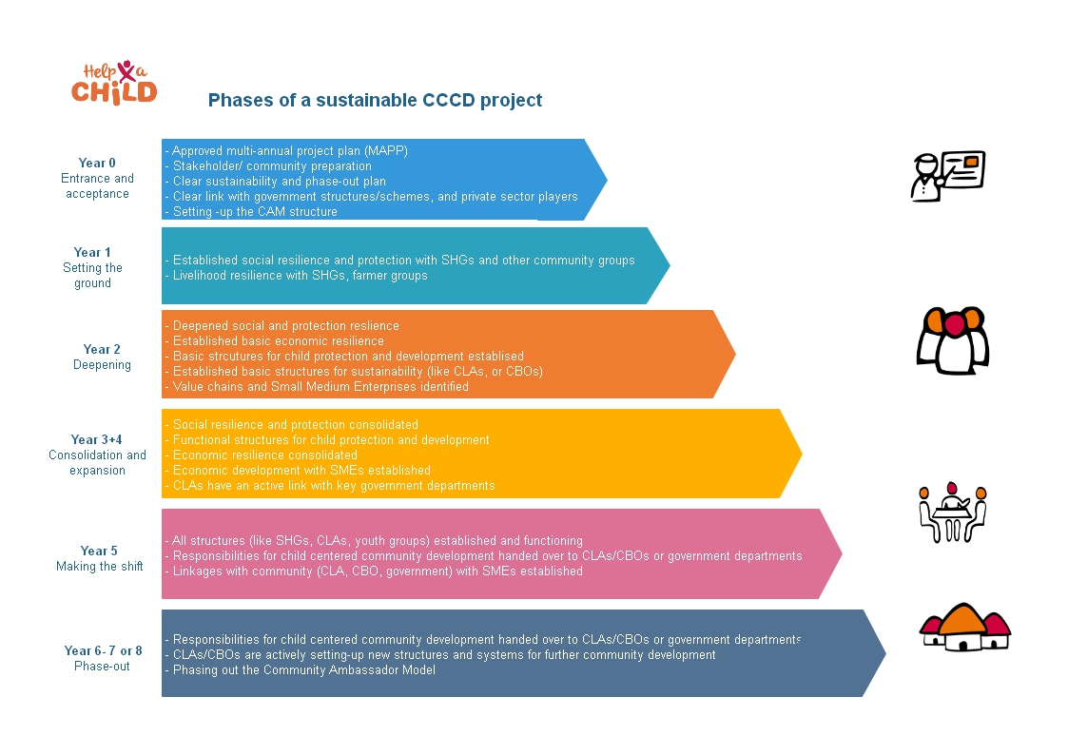

For more information on Help a Child’s vision on sustainability, please read our [**Sustainability guidelines**](https://howto.helpachild.org/our-standards/sustainable-programming).

**3.1 | Community ownership**

Help a Child recognizes that families and the communities are the owners and managers of the adaptive development process they go through. This ownership means that people feel and believe that it are their own efforts that are driving the process of change. They believe they contribute the maximum of their own human, financial and materials resources. In the process Help a Child travels along with the communities that aims at the self-reliance of its inhabitants and the community as a whole. Ownership is also about the communities owning up to the project, as they are convinced it meets their needs (this is why they need to play a role in the project design and monitoring). This will enable that the communities are willing to take charge of the project during implementation and after the project itself has phased out.

Please explain how you ensure community ownership in your project.

**3.2 | Local capacities and strengths**

Starting point for the capacity building is that communities already have knowledge and skills. The sustainability of projects depends on building on existing skills and development initiatives that have happened in the community in the past. Jointly community members need to determine what skills they need to increase their self-reliance towards well-being.

Explain how this project uses local capacities and strengths to ensure sustainability.

**3.3 | Phasing**

It’s crucial that through all stages of the project the community is in the driving seat, not because Help a Child wants them to, or because they get paid for it, but because they see the need for it, and have gained the confidence that they can. Therefore, it is needed, that toward the end of the project, all structures operate in ways that the community can continue them with their own resources: any payment for salaries, for meetings, for transport, for maintenance, for investments, for volunteers should be at the level where the community or individuals are able and willing to take care of it. Phasing out a project to reach that stage is a craft that requires planning.

Explain how you are phasing your project in such a way that from this year up to the very end (the ‘exit’) there is a clear philosophy on sustainability so that the community embrace the project and its anticipated change and can continue on their journey towards a better future after phase-out.

**3.4 | From facilitating to coaching**

To ensure community ownership and sustainability of development initiatives special facilitating and enabling skills of the involved staff of Help a Child and its partner organizations are required. The role of staff should also evolve over time from a more facilitating role at the phasing-in of a project to a coaching role at the end of a project.

Explain how the role of staff changes over time in your project and explain how this contributes to more ownership and sustainability.

**3.5 | Slow way versus the fast way**

Those projects that generated many positive effects and contribute towards sustainability have been able to ‘get things going’, to strike a chord in the community that keeps vibrating, to touch on an energy that started off further processes. Less performing projects may carry out a lot of activities, they may invest much, and they may achieve short-term results. But they remain the partners’ projects and activities while the community has remained on the receiving end. The box below simplifies two modes of working, the fast and the slow way.

|  |  |
| --- | --- |
| The fast way | The slow way |
| Provide what is needed. | Stimulate and facilitate capacity and agency. |
| Make investments from the project budget. | Use savings from the groups. |
| Pay government services so that they deliver. | Advocate for government services to deliver. |
| Do lobby and advocacy as organisation. | Facilitate lobby by community groups. |

The fast way generates quick results, but easily creates a dependent attitude, which is the opposite of empowerment. The ideal is the slow way, where people are the owner of their own process, where investments are made from what people save, where lobby is being done by the people when they have been sufficiently empowered to do so. In practice however, aspects of the fast way are sometimes necessary: to create goodwill, to motivate people to work on their own development when they have not yet been convinced that they are able to develop themselves, or with a careful mix of internal and external investments to speed up specific developments such as for the inclusion of vulnerable household or some constructive activities where no other funds are available. The major characteristic of good projects is that they are able to use the slow way as their main mode of working, and when elements of the fast way had to be used, they had the craftsmanship to prevent or offset the almost inevitable negative consequences.

Explain and reflect which elements of the ‘slow’ and ‘fast’ way of development are included in your project, and justify your choices.

**3.6 | Financial sustainability**

During the project you aim to slowly hand-over the project to the community. We therefore advise you to think on how the project can become more financially sustainable over the years. How do you for example work with incentives for volunteers that need to remain active after the life span of the project, do you have a gradual decline in your incentives? And how do you ensure the community can keep investing in their community after the project ended, are there any Income Generating Activities or Savings that they can use for this? And what system supports this?

Also ensure that during for example construction activities (hardware) the community is always actively involved in financial contributions or in-kind contributions. Please read the [**construction guidelines**](https://howto.helpachild.org/our-standards/construction-guidelines) of Help a Child in this case.

Explain how you ensure financial sustainability.

**3.7 | Exit strategy**

Help a Child and its partner organizations join the communities capacity enhancement process as facilitators, trainers and eventually especially as coaches for a limited defined period of time. From the beginning of the project it must be clear what the phases of development are and what the time frame is of the involvement of Help a Child and its partners comes to an end. Also roles and responsibilities between the community and Help a Child and its partners must be clear in the process of phasing out and handing over to ensure local ownership and sustainability.

Make sure communities have a say in how the phase-out should look like in their opinion, as to increase the likelihood of them actually taking over the project, as they have been involved in the design of the phase out strategy. They know what is expected of them, and this is in line with their own expectations and desires.

*Explain how you go about this process of preparations for exit.*

**3.8 | Linking & Learning with government authorities**

Explain how you will link with and learn from government authorities these final years. You need to revert back to your MAPP where this is also described and explain what part is applicable these final years. This can include Lobby & Advocacy initiatives. (Max ½ A4)

**3.9 | Linking & Learning with other stakeholders**

Explain how you will link with and learn from other relevant actors and service providers these final years. This can include Lobby & Advocacy initiatives (Max ½ A4)

**4 Organisational Development**

**4.1 | Organisational activities**

Related to the MAPP, what kind of organizational development activities are foreseen in these final years. You can think of staff training, performing organisational scans, implementation of child protection staff policy, etc. (Max ½ A4)

**4.2 | Expectations of external support**

Other than providing funds, is there any type of support you need or expect from Help a Child and/or other external support in these final years in order to implement your MAPP successfully?   
Think of training, support visits, coaching, etc. (Max ½ A4)

**5 FINANCIAL PHASE-OUT PLAN**

**5.1 | Finance and Administration plan**

Provide a list of the management letter issues of external audits and issues from internal audits of previous years and provide per issue information about how they are followed up. (Max ½ A4)

**5.2 | Planned Phase-out Budget**

Use the budget template which can be found [**here**](https://howto.helpachild.org/our-standards/program-phase-out) for submitting the Phase-out Budget. Submission of the budget and plan should be done in [**Project Connect**](https://projects.redeenkind.nl). For more information see the [**Project Connect Manual**](https://howto.helpachild.org/our-standards/manual-project-connect).

**Multi-annual project budget:**

Here, a rough estimation of the multi-annual budget needed to implement the project is requested. Since phasing of the project is crucial, we expect that the budget fluctuates over the years since activities will also be different over the years. The first preparatory phase will likely have a lower budget, during the intense years of the project with many activities the budget will be at its peak, at the last phase-out period the budget will likely go down again.

Below we show an example of how a project can be phased regarding the budget.

On the next page you see an example of the multi-annual and phase-out budget in Word with some examples of possible budget lines.

**Financial sustainability:**

During the project you aim to slowly hand-over the project to the community. We therefore advise you to think on how the project can become more financially sustainable over the years by including a decline in costs of for example:

* Expected number of staff members involved
* Expected number of volunteers/community facilitators involved
* Expected payment of per diems for trainings, transport etc. to participants

And an increase of costs of for example:

* Own contribution communities for salary of trainers, investments, etc. by communities
* Own contribution communities for child well-being activities – e.g. education etc.

Below an example of the set-up of the phase-out budget (use the Excel version which is accessible in the [**knowledge portal**](https://howto.helpachild.org/our-standards/program-phase-out).

