Community Challenge Reporting Template
[TITLE PROJECT]

[Year and Country]

[Insert logo partner organisation]

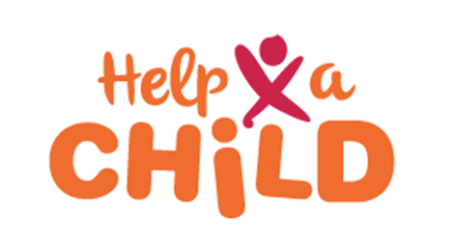
<Date>
Table of Contents

1. Executive Summary
2. Community mobilisation
3. Participatory tools and assessments
4. Community Visioning and Planning
5. Parenting
6. Setting up Self Help Groups
7. Community Ambassador Model (CAM Selection)
8. Conclusion

Executive Summary
Max ½ page
Provide brief highlights of the content of the community challenge report.

Community Mobilization
Max ½ page
Briefly describe the process undertaken to mobilize communities towards the process of CC an how many villages and how many people were mobilized.

Participatory tools and assessments

Please present the outcomes per tool you have used in collecting and documenting beneficiary and community views on the situation in the community, including the identification and analysis of the root causes of child poverty. Click on the tool for the link.
Step 1: Entrance meeting
Who: community leaders
Number of sessions: 1
How: Presentation and open dialogue
Step 2: Exploring the community
Who: various stakeholder groups (peer group meeting)
Number of sessions: 4
How: Use of participatory tools
- Session 2.1: What does the community look like?
(Tools: Community mapping I and Venn diagram I)
- Session 2.2: Who likes it where?
(Tools: Community mapping II and/or Children's wellbeing/development matrix)
- Session 2.3: Culture now and in the past
(Tools: Historical timeline)
- Session 2.4: Gender roles
(Tools: 24-hour schedule, Take a step, Venn diagram I)

Step 3: Sharing and caring I
Who: the whole community (plenary meeting)
Number of sessions: 1
How: Presentations

Step 4: What's the challenge?
Who: various stakeholder groups (peer group meeting)
Number of sessions: 4
How: Use of participatory tools
- Session 4.1: What are the challenges for our per group?
(Tools: Vulnerability ranking)
- Session 4.2: What are the challenges for other age groups?
(Tools: Vulnerability ranking - to be filled out for other stakeholder groups)
- Session 4.3: What is the current status of child wellbeing in the community?
(Baseline survey – Tool: Child Status Index)
- Session 4.4: What is the current empowerment status of the community?
(Baseline survey - Tool: Community Empowerment Scorecard)

Step 5: Sharing and caring II
Who: the whole community (plenary meeting)
Number of sessions: 1
How: presentations
Step 6: Knowing our strength
Who: various stakeholder groups (peer group meeting)
Number of sessions: 2
How: Use of participatory tools
- Session 6.1: Individual and community strengths + case and effect tree
(Tools: Resource bag, Cause and effect tree)
- Session 6.2: Prioritize actions and check / make the link with child wellbeing + CDC member(s) selection
(Tools: Pairwise ranking, Child wellbeing vision's matrix)
Step 7: Finding common ground
Who: the whole community (plenary meeting)
Number of sessions: 2
How: Presentations and use of participatory tools
- Session 7.1: to share priorities raised in the stakeholder groups
(After this meeting, the CDC members will work out the Community Action Plan)
- Session 7.2: to present the draft community action plan for community approval
(Tools: Community Action Plan)

Community Visioning/Planning
Max ½ page
Present here the Community Action Plan and the way you have discussed this plan with the community.

Parenting
Max 1/2 page
Document the process of establishing the parenting challenge, indicating how many parents have committed to participate, and the extent to which men have been involved.

Setting up Self Help Groups
Max 1/2 page
Describe and document the process of establishing/forming self-help groups (SHGs).

Community Ambassador Model (CAM) Selection
Max ½ page
Describe the criteria for selecting CAM from all the villages targeted and document the process of selecting.

Conclusion
Max ½ page
Highlight key points of the community challenge by way of summing up the exercise, also challenges during the process can be described here.

